Beyond Limits Charity Website

User Manual

This document provides crucial pieces of information on how to navigate the public webpages and the Admin page, as well as how to make use of the features included in the admin page.

For each page, information about the intended purpose will be provided as well as editing choices and limitations. Most of the content of the pages is editable using the admin page so the appropriate content will be defined so that the user shall know their options clearly.

Menu:

1. Public Webpages
   1. Navbar
   2. Footer
   3. Home Page
   4. About Us Page
   5. Events Page
   6. How We Can Help Page
   7. Volunteer Page
   8. Blog Page
2. Admin Page
   1. Tabs
   2. Home Tab
   3. About Us Tab
   4. Events Tab
   5. How We Can Help Tab
   6. Volunteer Tab
   7. Blog/Testimonials Tab
   8. General Editors
   9. Statistics
   10. Database

# 1. Public Webpages

These are the pages of the website that everyone can see. To navigate through the different public pages (All pages excluding admin page) can be done using either the navbar, the footer or by inputting the exact page url in the browser’ s(Google Chrome, Safari, Firefox etc.) search bar.

## 1a. Navbar

The navbar, as seen, will appear in all of the public webpages the same. It remains in a fixed location at the top of the screen and has a slightly darker white colour as to distinguish it from the rest of the page. On it, the logo is displayed as well as the website various pages: 1.c – 1.h. The contents and styling of the navbar cannot be changed using the admin page. 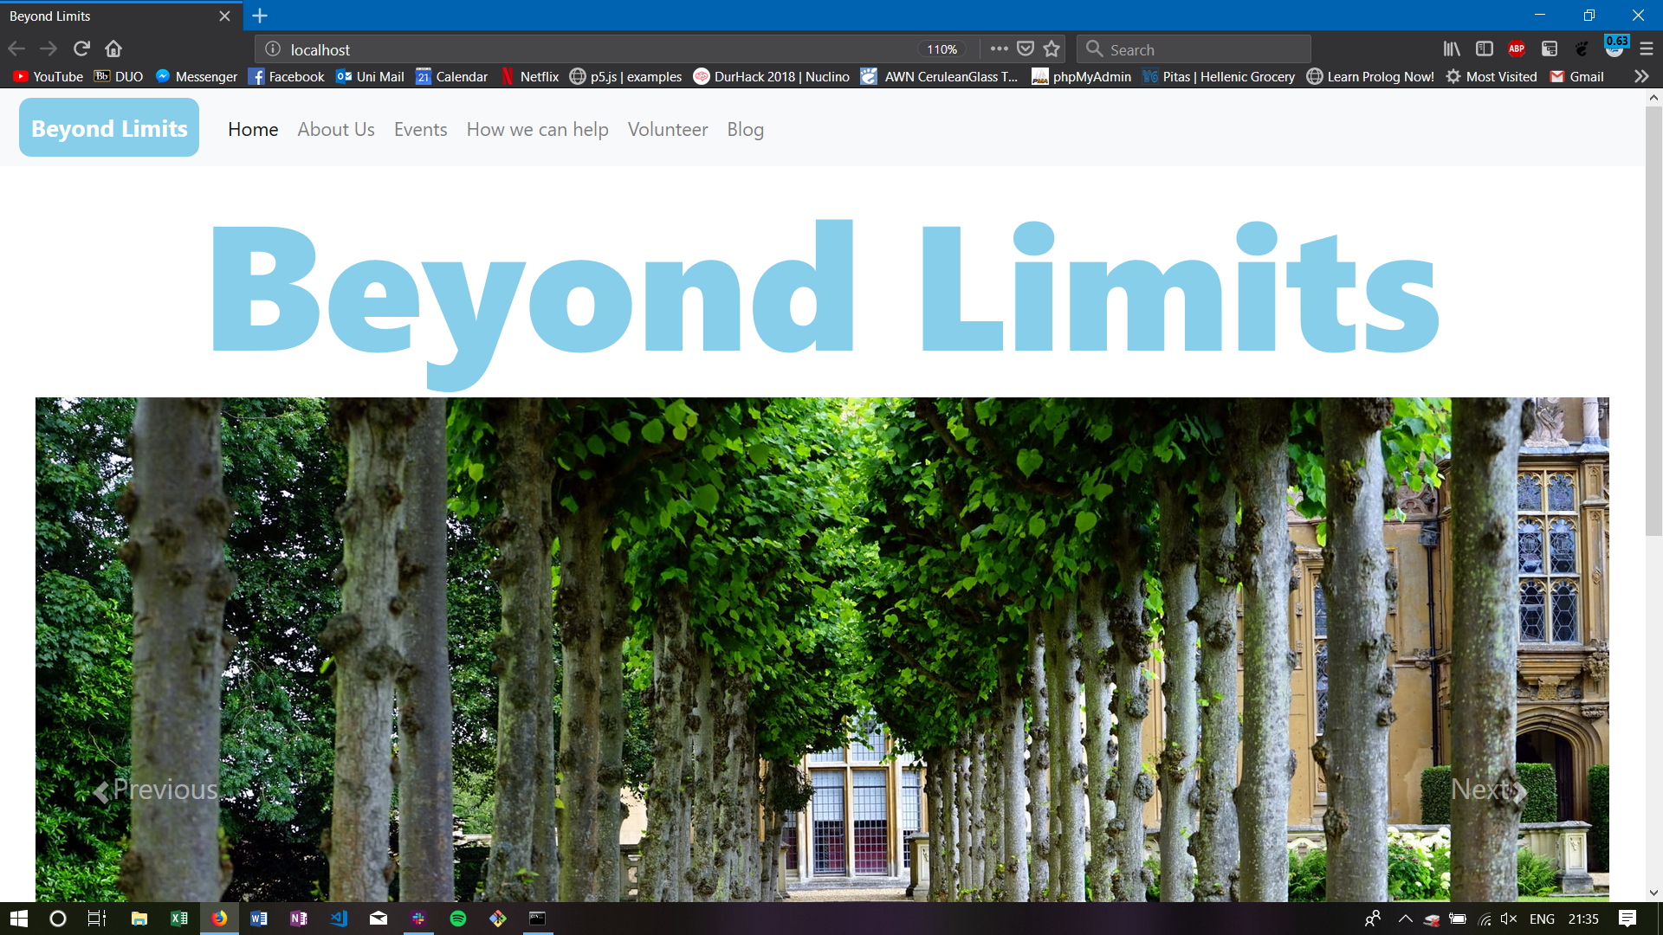

Figure 1: Navbar

## 1b. Footer

The footer, along with the navbar is also displayed on all the public webpages. It remains at the bottom in a fixed position and it is coloured a variation of blue to distinguish it from other items of the site. In the footer, other contact methods are provided such as Telephone, Facebook and Email for people to use, as well as quick links to the pages of the site. The content and styling of the footer cannot be changed from the admin page.

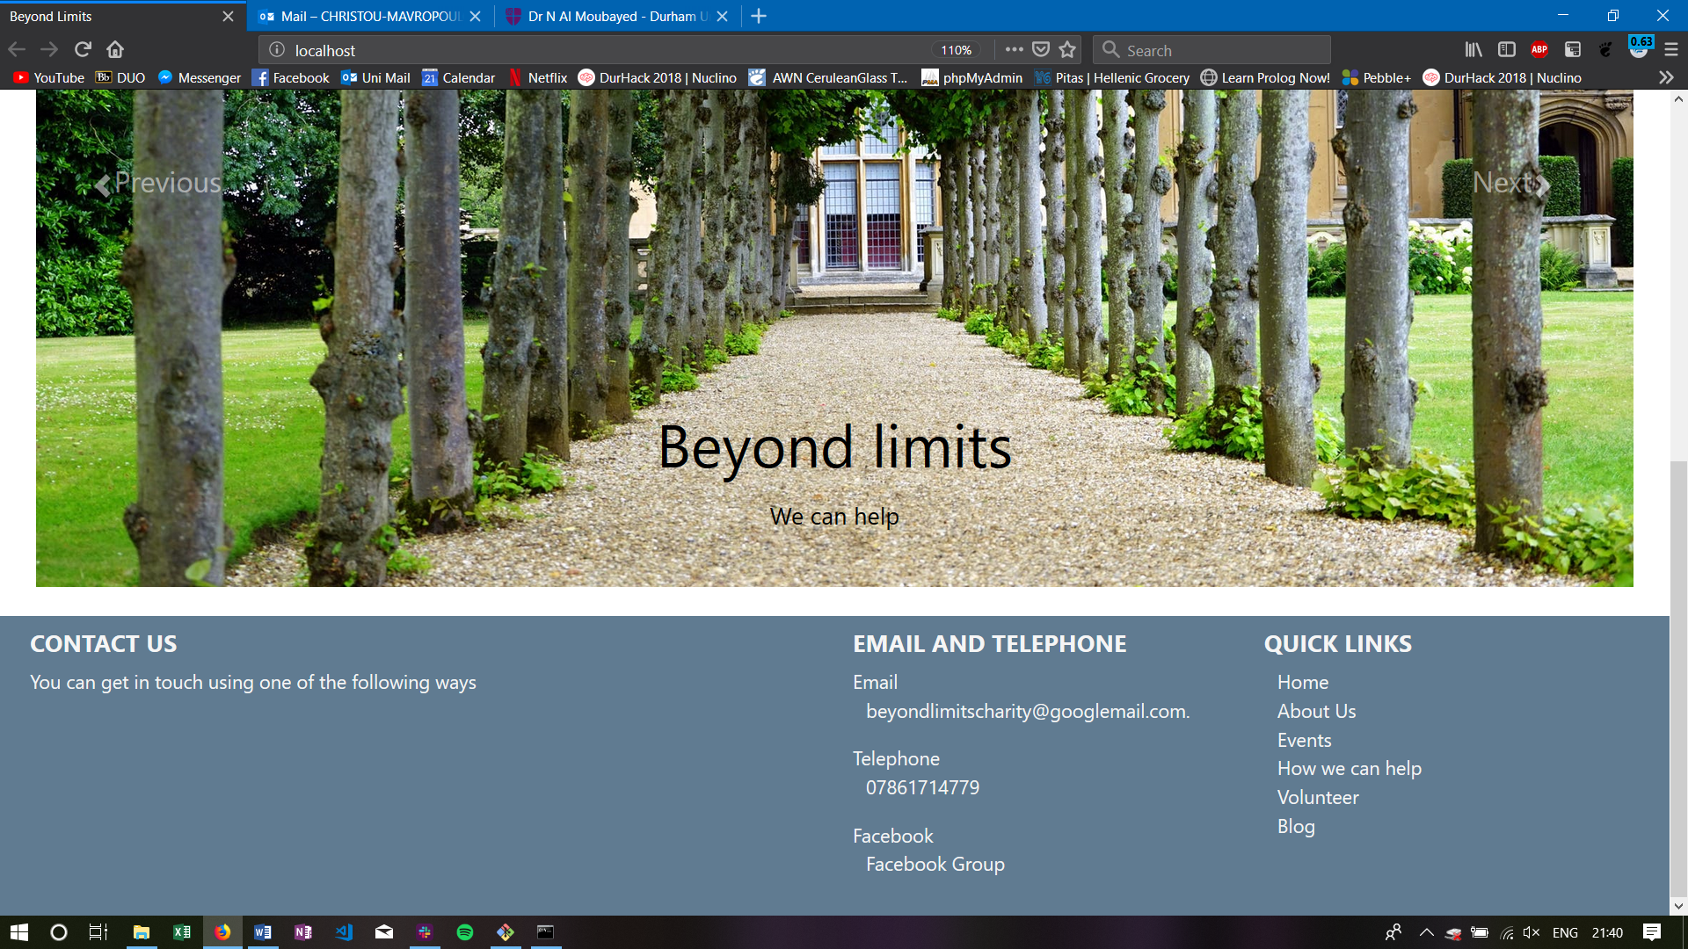

Figure 2: Footer

## 1c. Home Page

The home page will be the first point of contact of a user with the website. That’s why we used a simplistic and intuitive design. There, a collection of photos and/or videos is displayed in the “image carousel”. The contents of these photos and videos can be edited through the admin page. The text displayed on top of each of the pictures can also be edited through the Admin Page -> Home Tab.

## 1d. About Us Page

The about us page is meant to be a way for people interested in Beyond Limits to find out more about the charity and the services it provides. In order to change the text on the page, the administrator simply must navigate to the Admin Page -> About Us section and change the content on the editor. (see section 2c).

## 1e. Events Page

The Evets Page provides information about the upcoming and/or past events depending on what events are active in the database. The events are displayed in blocks that hold the photo, and the title of the specific event. If no photo is provided, a predetermined photo will be used. If a user is interested in any of these events, they can left-click on the *Expand* button, which is set to be on top of each event image. Once clicked, the description and dates of the specific event will be shown to the user, below the event. Multiple event descriptions can be shown, one below the other, in order that the events are initially shown on the page.

The events are automatically pulled from the database (under Events table) and shown on the site. If an administrator wishes for an event to not be shown they can do so by deleting it from the table from the Admin Page. There are 2 ways to do this and both are referenced below (SECTION FOR DELETING EVENT). Once the event has been deleted, a copy of it will be kept under Events Archive table of the database for reference.

An event can be created through the Admin Page and will be displayed first. An event can also be edited after creation if needed using the Admin Page.

## 1.f How We Can Help Page

This page is divided in 3 parts. The first one is the tab that is always going to be displayed when a user lands on this page. The purpose of the first tab is to hold general information about your services and maybe some other information that is not included in the About Us section of the website.

The second tab holds the form that a potential user can fill out in order to contact the admins of this page. If the fields have been filled out correctly, the form is going to be sent directly to your email with the details formatted in a easily readable way. If the form is send successfully, the user will receive an alert that the form has been submitted, else an error will appear which will prompt the user to try again. This section of the website cannot be edited.

The third and last tab on the page is meant for storing More Information about the services you provide or anything else that the admin might find useful. The content of this tab can be edited in the Admin Page -> How We Can Help -> More Information

## 1.g Volunteer Page

The Volunteer Page provides visitors the chance to find out more about what it means to be a volunteer for Beyond Limits as well as having an online form that they can fill out. It is split in 3 tabs. The first tab has some general information about the application. This can be edited from the Admin Page. The second tab has the online form that if filled out, is sent to the specified email. The third tab holds more information about the volunteers and can also be edited from the Admin Page.

## 1.h Blog Page

The blog page displays both Blogs and Testimonials. Both, are stored in the database and can be created, edited or deleted through the Admin Page, under the Blog tab. Blogs, show up on the left of the screen while testimonials on the right. All the blogs and testimonials that are in the database will be shown unless deleted.

Both categories will display the articles in a reduced format, where only a fixed amount of text will be displayed. That text is going to be taken from the start of the each piece of text. If the user wishes to read the entire post, they can do so by clicking the *More Info* button located under each post.

The testimonials can also hold pictures of the people they are referring to.

# 2. Admin Page

The Admin Page is the portal to editing the website. Accessing it requires a username and a password and more accounts can be added by using the Database Tab.

## 2.a Tabs

The Admin Page is split into 8 separate tabs. The first 6 (Home-Blog) are the same to the tabs of the website. If the administrator wishes to change something on the public site, and that item is editable from the Admin Page, they simple have to navigate to the tab with the same name as the page.

## 2.b Home Tab

In the Home Tab, the text of the carousel pictures can be edited, new photos can be added and photos already showing can be deleted.

## 2.c About Us Tab

In the About Us Tab, there exists a single editor on which the current text of the About Us Page is displayed. This can be edited. To change it, the admin must click submit and confirm their choice on the alert that the website will create.

## 2.d Events Tab

In the Events Tab, there exist 2 main buttons. Create Event and Edit Event. By clicking Create Event, the appropriate fields will appear. The administrator should fill out all the fields with the appropriate values (e.g. for Attendance, input must be a number). Once all the information is in the fields, the user should click Submit.

The Edit Event button will display all the events that are shown in the website. Next to each event, there are 2 buttons, Delete and Edit. By clicking Delete (and confirming your choice), the specific event is deleted, and the page reloads. By clicking Edit, the fields of the Create Event will be filled with the specific event information so that the user can change the information they need. The user might need to click on the Create Event Tab to see the fields. After done editing, click on Edit Event to change the information held in the database. If everything is successful you will be prompted with an alert saying so. To cancel editing an event simply quit, or reload the page.

## 2.e How We Can Help Tab

The tab is split into 2 sub-categories: *What We Can Do for You* and *More* *Information*

The user must select one of these tabs to edit. In both there exist an editor that displayed the text currently displayed on the public website. The user can change that text and click submit to change it on the website as well.

## 2.f Volunteer Tab

The tab is split into 2 sub-categories: *How do I apply?* and *More* *Information*

The user must select one of these tabs to edit. In both there exist an editor that displayed the text currently displayed on the public website. The user can change that text and click submit to change it on the website as well.

## 2.g Blog Tab

The Blog Tab contains function to create, edit and delete both blogs and testimonials. For both Blog and Testimonials (there areas are separate and are annotated by the appropriate title) there is a button: *Show/Hide* *Blog/Testimonials* *Posts*. By clicking it, the posts currently on the website will be displayed and an edit and delete button next to each one. Below this button, there is a text field for a title of a new post and an editor for the main body of that post. Inserting information in both and clicking *Post* which is located below the editor, the blog will be displayed on the site.

If someone wishes to edit a post using the above button, the information will be displayed on the editor, overwriting the information currently there. If then this text is edited and the Edit Post button is clicked, the post will be updated, and the new content will be visible in the website. Deleting a Post will reload the website.

## 2.h Statistics Tab

The purpose of the Statistics Tab is to display information that exist in the database, in a format that is easy to read and understand. On the left of the page, the graph upon which the graphs are plotted is located and shown. On the right there are 2 drop-down menus that hold the option about what is going to be displayed in the graph (x and y axis). Depending on the choice for the x-axis, some options for the y-axis might be blocked.

## 2.i Database Tab

The Database Tab provides the interface with the database that information is stored. On load, it only holds 2 dropdown menus. The first one provides the Tables of the database. The second one provides the option of what the user wants to do. SELECT will display information and data, DELETE will provide fields to delete items from the database and INSERT will provide fields to insert new items in the database.

To show any of these fields one must simply click on any of the two menus.

**SELECT:**

Select will provide the columns of the selected table.

If you do not fill out any of the text inputs then by just pressing search, the entire table will be shown below.

It will also provide 2 text fields and 2 drop-down menus. With the menus you can select the columns of the table that will be used when you input something in the fields. For example, if the table: *Volunteer* is selected at the start and you want to see the volunteers whose name is Jack, you can select *First Name* from the columns and type *Jack* in the first input field. If you then click search, the people named Jack will appear. (this is equivalent to First Name = Jack)

You can also add a second field, with a different column and the operator AND or OR. So you can have people named Jack OR Sandy (with both columns as first name) but you can also show results for people with first name Jack AND last name Smith, to be more specific. The same actions and rules apply to all the tables (i.e. Events, Accounts etc.).

**DELETE:**

Similarly, with select the same fields and menus will appear for the delete method. However, instead of showing the results, this function will delete them. Before doing so, the website will ask you for confirmation about the action. Because clicking Delete without any input would delete the whole contents of the table, that action is not allowed and is restricted from the site.

**INSERT:**

Insert will print out the columns of the selected table and below each column it will print a text field. Filling out all the text fields and submitting the information will reload the page and upload that information to the database. You can view the newly added information using the SELECT method.